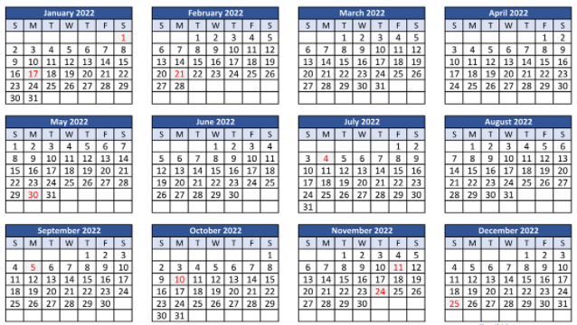
2022 Recycling Schedule

January: 4th and 18th February: 1st and 15th March: 1st and 15th April 5th and 19th
May 3rd and 17th June 7th and 21st July 6th and 19th August 2nd and 16th
September 7th and 20th October 4th and 18th November 1st and 15th December 6th and 20th

